Projecpt Documentation

1.Introduction

Project title:Citizen AI – Intelligent Citizen Engagement Platform

Team members:Manjari .G

Backia. S

Harinisri .N

Janani .MS

2.Project Overview

* Purpose:

The purpose of Citizen AI is to enhance citizen engagement and improve communication between governments and the public using Artificial Intelligence. The platform provides transparent access to policies, forecasts resource needs, generates eco-friendly suggestions, and allows real-time feedback. This ensures better governance, sustainability, and inclusive participation.

* Features:

• Conversational interface via Gradio

• Integration with IBM Granite models on Hugging Face

• Lightweight deployment using Google Colab (T4 GPU)

• Public sentiment tracking and visualization

• GitHub integration for code sharing and version control

1. Architecutre:

• Frontend (Gradio): Simple and accessible UI for citizen queries

• Backend (Google Colab Runtime): Python + Transformers, Torch, Gradio

• Model Integration (IBM Granite): Uses granite-3.2-2b-instruct for fast inference

• Version Control (GitHub): Stores project notebook, scripts, and outputs

4.Setup Instruction:

Prerequisites :

• Python (Google Colab runtime)

• Hugging Face account for IBM Granite models

• Gradio library

• GitHub account for versioning

• Installation :

• Open Google Colab → New Notebook• Change runtime → Select T4 GPU

• Install dependencies: !pip install transformers torch gradio -q

• Load Granite model from Hugging Face

• Run notebook cells to start Gradio app

1. Folder Structure:

• citizen_ai.ipynb – Main project notebook

• requirements.txt – Dependencies list

• README.md – Project overview (GitHub)

• output/ – Application screenshots / reports

6.Runninga the Application:

• Launch Colab notebook

• Select T4 GPU runtime

• Install dependencies

• Run notebook cells

• Gradio generates a shareable URL → Open app in browser

7.API Documentation:

• POST /ask – Accepts citizen query and returns AI-generated response

• GET /sentiment – Retrieves sentiment analysis dashboard (future)

8.Authentication:

• Presently runs in open mode for demo

• Future security upgrades:

• - Hugging Face API keys

• - JWT-based authentication for access contro

9.User Interface:

• Minimal Gradio interface with text input and response area

• Auto-generated shareable link from Google Colab

• Works on any browser

10.Testing:

• Unit Testing: Verified installation and model loading in Colab

• Manual Testing: Citizen queries tested via Gradio UI

• Edge Cases: Long queries, irrelevant prompts tested

11.Screenshot:

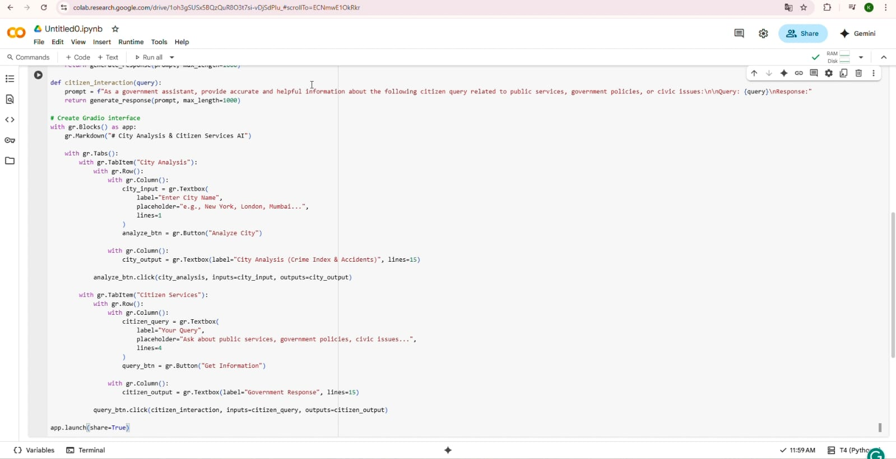

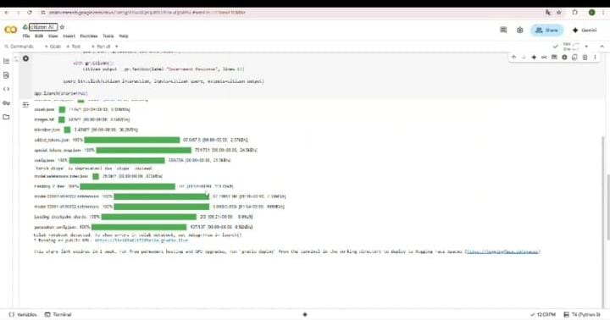

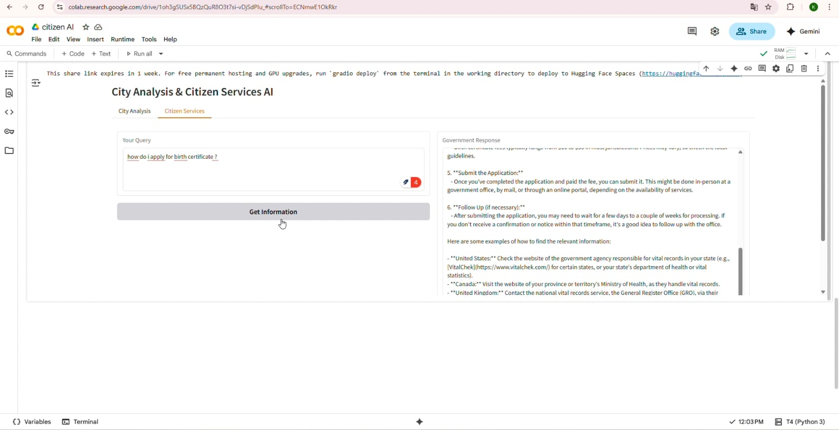

1. Known Issues:

• Free Colab tier has limited GPU availability

• Hugging Face model download requires internet

• No persistence across Colab restarts

1. Future Enhancement:

• Deploy with IBM Watsonx API for enterprise use

• Use FastAPI backend for production

• Sentiment dashboard with real-time visualization

• Multi-language citizen query support

• Persistent cloud-based hosting